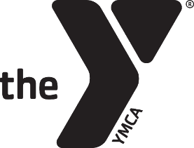
Wayne County YMCA
Membership Hold Authorization Form
For Bank Draft Members

I, __________________________________________________________, give authorization to the
Wayne County YMCA to put a hold on my YMCA Membership for the months
indicated below:
 | January |  | July
 | February |  | August
 | March |  | September
 | April |  | October
 | May |  | November
 | June |  | December

I understand that even though my membership is on hold I am still required to pay $5.00 per month to keep it on hold. This amount will be deducted from my account on file for each month on hold. I understand that as of ___________________ my monthly payment will return to ________________.
*If the Y is closed for more than 50% of a month due to COVID-19 (or other incident) I will not be charged the $5.00 fee for holding.

______________________________________________________________ ____________________________
Member Signature Date

______________________________________________________________ _____________________________
Staff Signature Date

